Assignment

Problem Statement:

To design a system that collects data about energy consumption from different villages and generate an on-demand energy consumption report per village, for the given duration.

Technical Specification:

The following steps are involved in generating the energy consumption report,

1. The system has an API that is called by the electricity counters.

Request: POST /counter_callback

Response : {“counter_id” : “1”, “amount” : “10000.123”}

Assumption: This API is called every hour, and the response contains ‘counter_id’ represents each village that holds the electricity counter and ‘amount’ represents the consumption charges.It is assumed, that the response always holds a single counter value.

2. To get additional information about the counter, for example to render the village name, the following external API is called.

Request: GET /counter?id=1

Response : {“id” : “1”,”village_name” : “Villariba”}

Assumption : Its assumed that the response always returns a constant value, for the given id. Once the village name is mapped with an id, it won’t be updated again.

3. The system will expose the following API, to generate the energy consumption report per village, for the given duration.

Request: GET /consumption_report?duration=24h

Response: {“villages”:[{“village_name” : “Villariba”, ”consumption” : “1000.123”},
{“village_name” : “Villies”, “consumption” : “18978.897”}]
}

Assumption: The duration value is dynamic and its assumed that the consumption charges holds an approximate value, if the exact duration timelines are not met.

Tools and Frameworks:

- Programming Language - Java 11
- JEE Enterprise framework - Spring 3.1
- ORM Framework - Hibernate 4.2
- Database – MySQL 5.7
- Project Management Tool – Maven 3.5.x
- Logging Tool – slf4j 1.6
- Jackson Data Binding
- Testing Tool – Junit 4.7

Architecture:

Class Diagram:

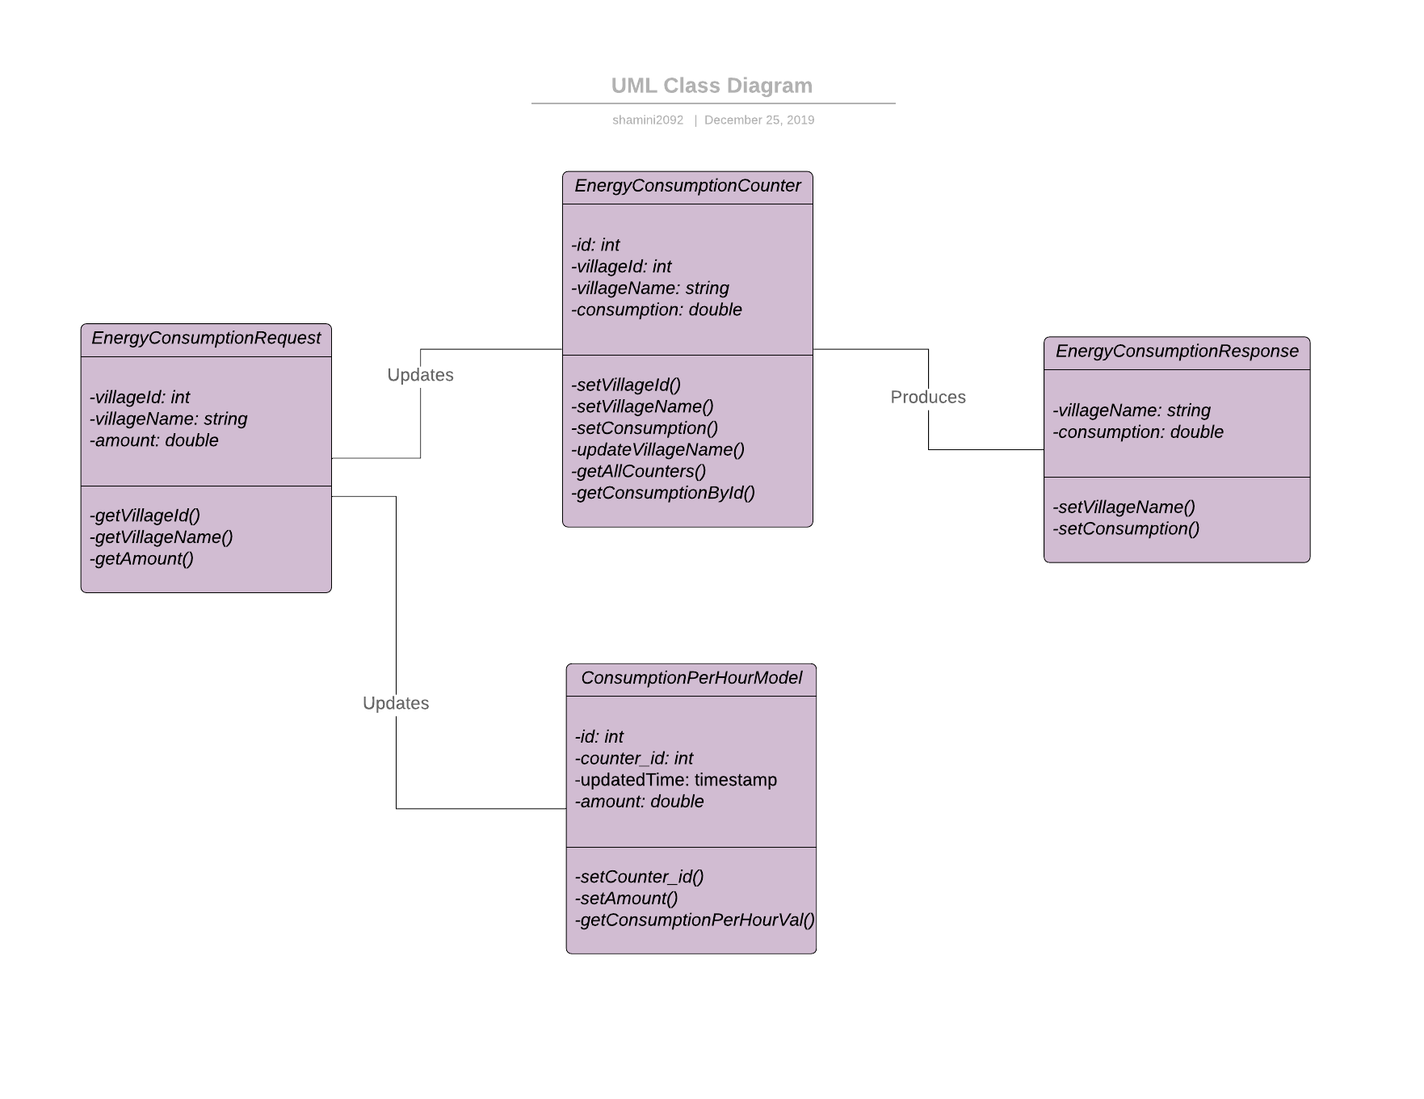

Working Model:

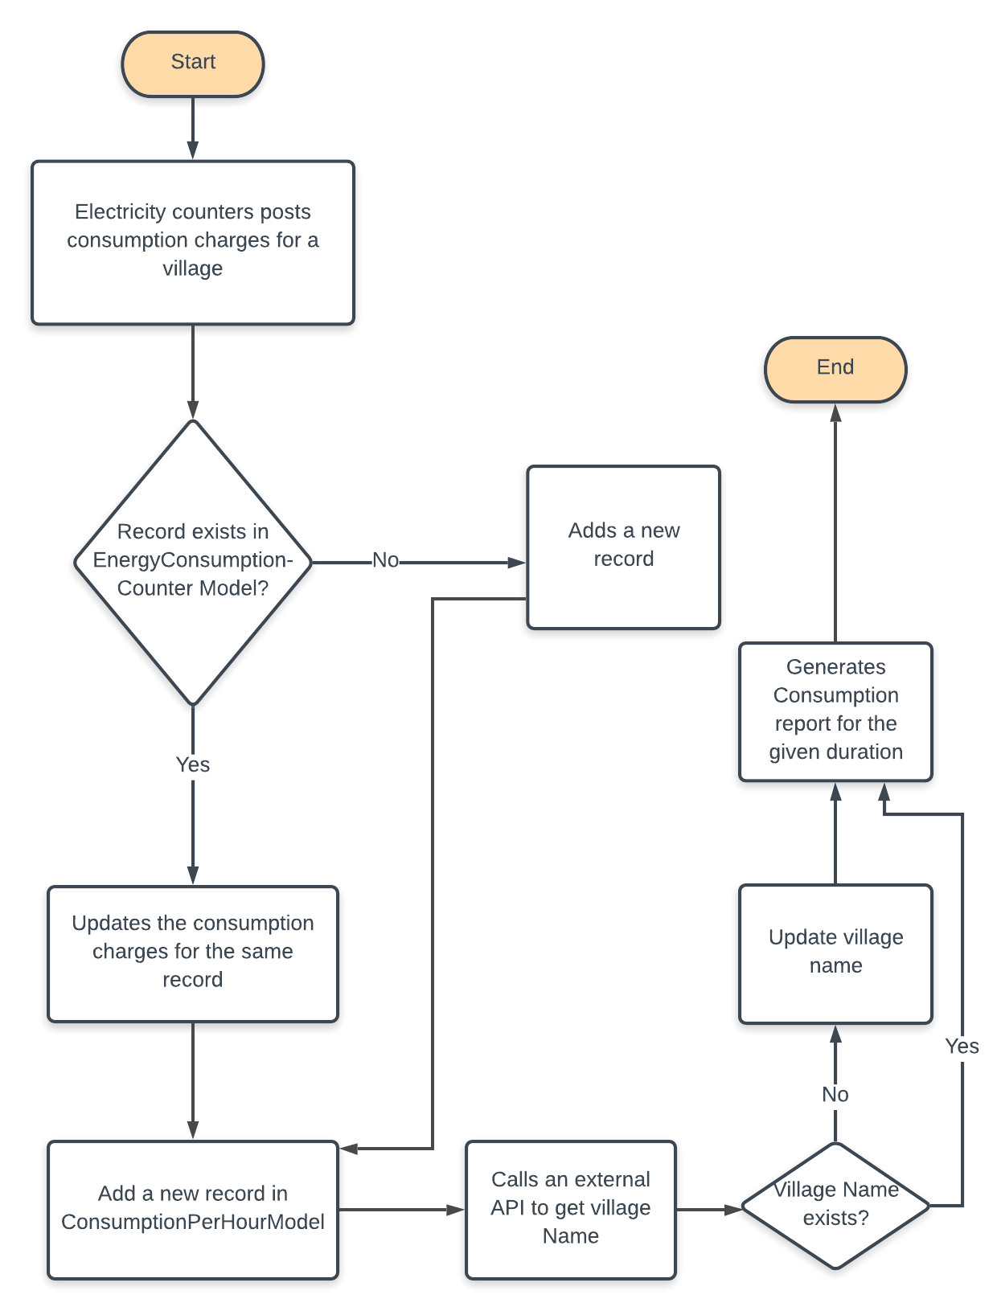

Output Snippets:

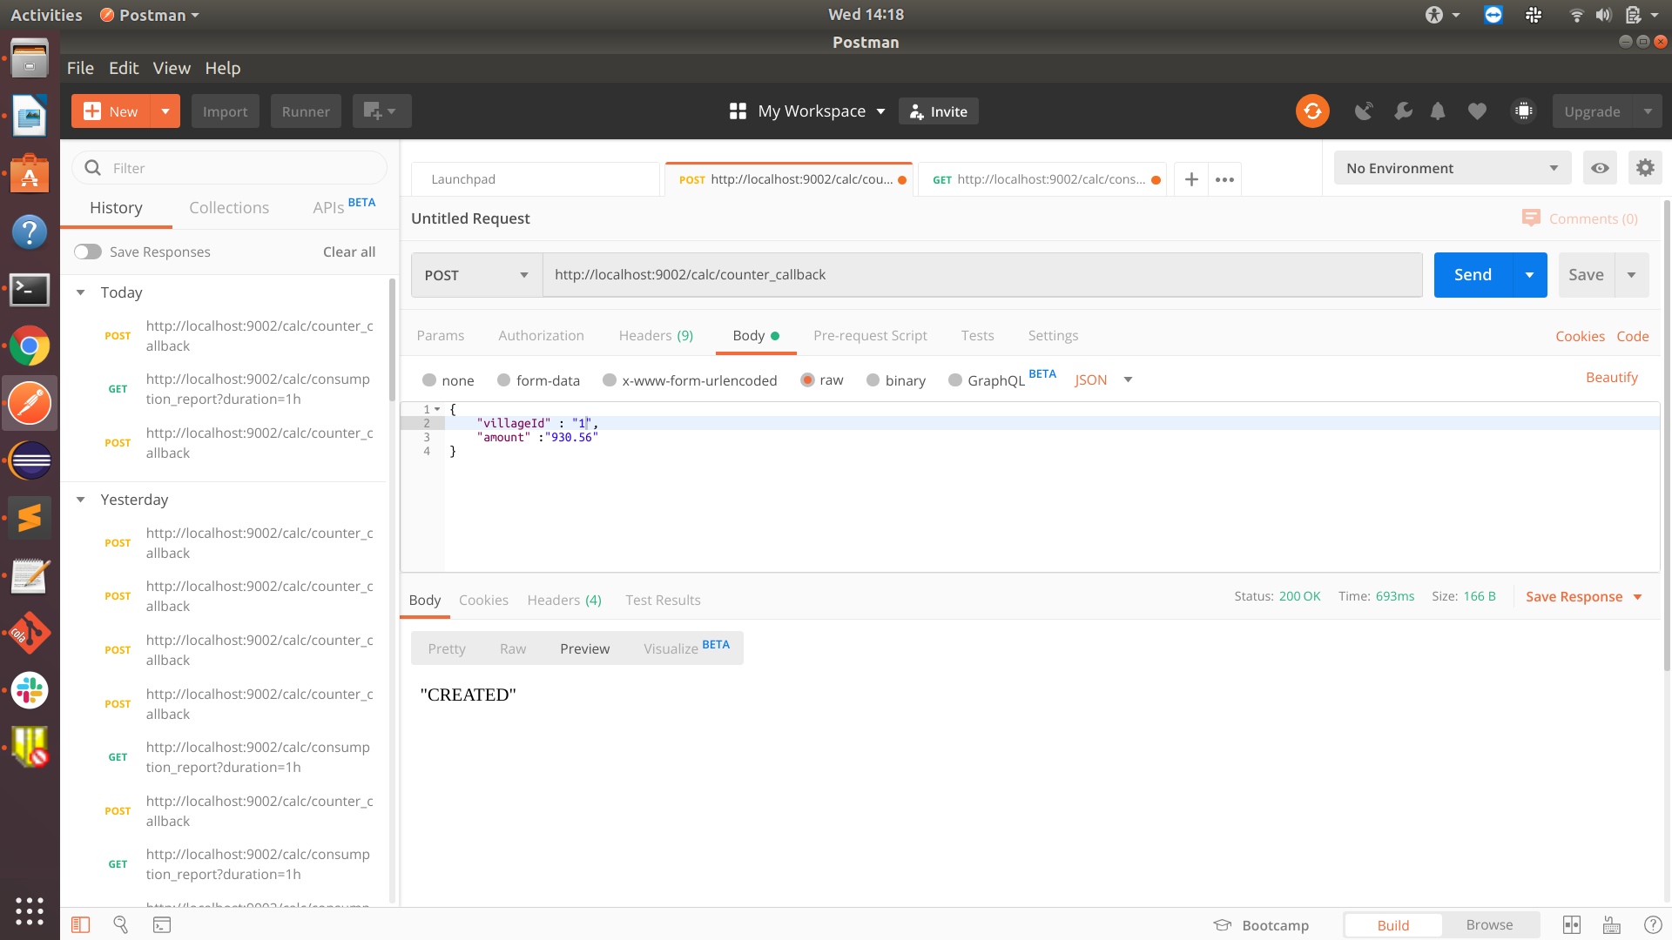

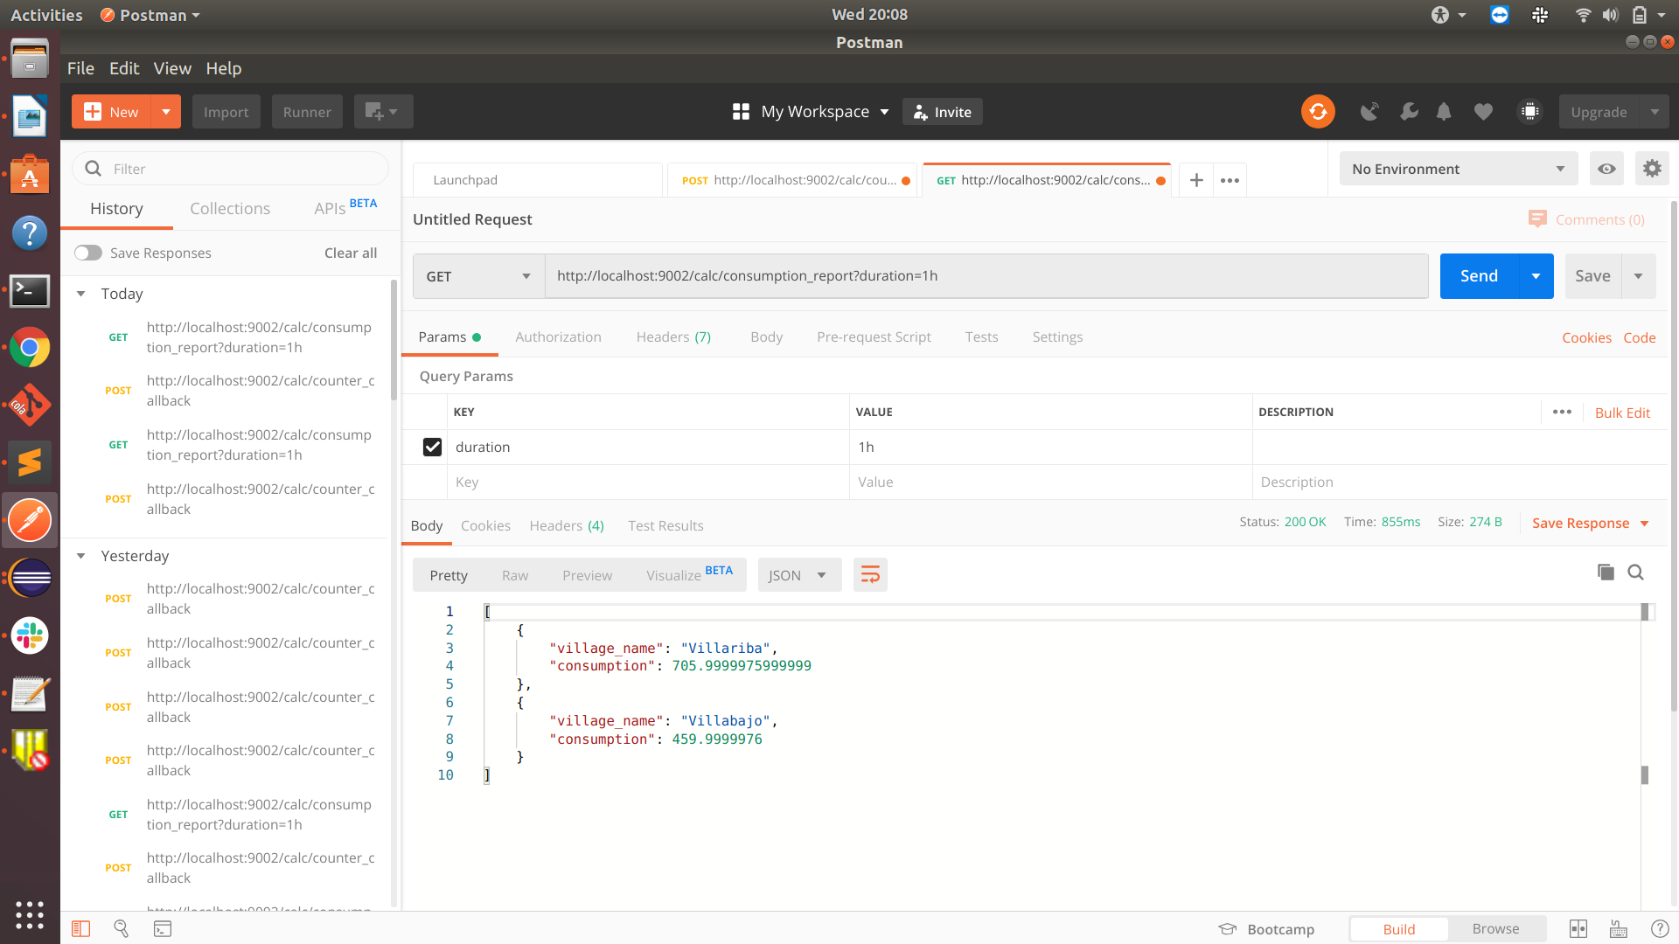

Further Improvements:

- A cronjob can be created, to purge the records in ConsumptionPerHourModel at the end of every month, as this table contains counter records on hour basis.
- The existing relational database can be migrated to flat file based system(csv structured format), in future releases.

